**NEXUS 1000V Configuration Script Instructions**

***Revisions:***

*V1.0 Initial release to the general VCE D&I audience.*

*V1.1 updated error handling, made data file save default, and added timestamp.*

**About**

These instructions are for running the NEXUS 1000v Configuration CRG report PowerShell Script. To run this script, PowerShell must be installed on the Windows laptop/server that the script will be run from. The Windows laptop/server must also have connectivity to the NEXUS 1000V system in the Vblock for the default collection of NEXUS 1000V data. The system must have Excel COM object to generate the Compute tab of the Configuration Resource Guide default output.

**Pre-Requisites**

The script requires different pre-requisites based upon the mode being ran. By default data collection and report generation are done at the same time. For this the prerequisites are PowerShell, access to the NEXUS 1000V, proper NEXUS 1000V credentials, and Excel loaded. For generating a data dump, you do not require Excel to be loaded. For generating a report, you do not require credentials or access to the NEXUS 1000V.

**Modes of the Script**

The script has 4 modes:

* Default: Connect to NEXUS 1000V grab, grab data, build excel object, display report, and exit
  + N1K-CRG-V1.1.ps1 <NEXUS 1000V IP address>
  + N1K-CRG-V1.1.ps1
* Pull configuration: Connect to NEXUS 1000V grab, grab data, DO NOT dump the data to a file, build excel object, display report, and exit. The data dump output is the NEXUS 1000V cluster name with a .data suffix
  + N1K-CRG-V1.1.ps1 <NEXUS 1000V IP address> -noWrite
  + N1K-CRG-V1.1.ps1 –noWrite
* Pull configuration only: Connect to NEXUS 1000V grab, grab data, dump the data to a file and exit
  + N1K-CRG-V1.1.ps1 <NEXUS 1000V IP address> -noexcel
  + N1K-CRG-V1.1.ps1
* Offline report: grab the data to a file, build excel object, display report, and exit
  + N1K-CRG-V1.1.ps1 <filename> –Readin

**Instructions**

1. For Default behavior,
   1. From a PowerShell CLI, run the script as follows:

**.\** **N1K-CRG-V1.1.ps1**

* 1. Enter IP addresses to reach the NEXUS 1000V

1. The script will prompt you for the admin password of the NEXUS 1000V.

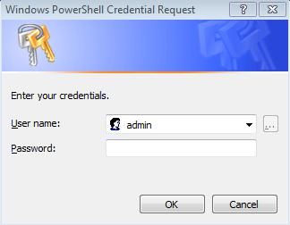

1. The script will now collect the data, build the Excel data.

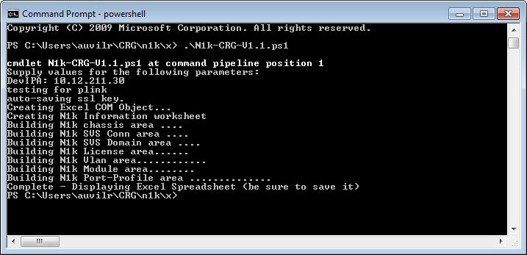

1. Upon completion the script will launch Excel reminding you to save the workbook and exit.

